SDLC, Software Development Life Cycle is a process used by software industry to design, develop and test high quality software’s.

The SDLC aims to produce high quality software that meets or exceeds customer expectations, reaches completion within times and cost estimates.

* SDLC is the acronym of Software Development Life Cycle.
* It is also called as Software development process.
* The software development life cycle (SDLC) is a framework defining tasks performed at each step in the software development process.

**What is SDLC?**

SDLC is a process followed for a software project, within a software organization. It consists of a detailed plan describing how to develop, maintain, replace and alter or enhance specific software.

The life cycle defines a methodology for improving the quality of software and the overall development process.

The following figure is a graphical representation of the various stages of a typical SDLC.

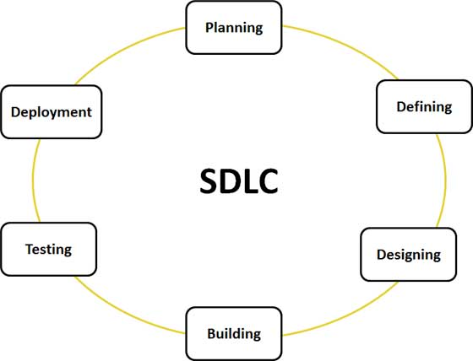

A typical Software Development life cycle consists of the following stages:

**Stage 1: Planning and Requirement Analysis**

Requirement analysis is the most important and fundamental stage in SDLC. It is performed by the senior members of the team with inputs from the customer, the sales department, market surveys and domain experts in the industry.

This information is then used to plan the basic project approach.

**Stage 2: Defining Requirements**

Once the requirement analysis is done the next step is to clearly define and document the product requirements and get them approved from the customer or the market analysts. This is done through .SRS. . Software Requirement Specification document which consists of all the product requirements to be designed and developed during the project life cycle.

**Stage 3: Designing the product architecture**

SRS is the reference for product architects to come out with the best architecture for the product to be developed. Based on the requirements specified in SRS, usually more than one design approach for the product architecture is proposed and documented in a DDS - Design Document Specification.

This DDS is reviewed by all the important stakeholders and based on various parameters as risk assessment, product robustness, design modularity , budget and time constraints , the best design approach is selected for the product.

A design approach clearly defines all the architectural modules of the product along with its communication and data flow representation with the external and third party modules (if any). The internal design of all the modules of the proposed architecture should be clearly defined with the minutest of the details in DDS.

**Stage 4: Building or Developing the Product**

In this stage of SDLC the actual development starts and the product is built. The programming code is generated. If the design is performed in a detailed and organized manner, code generation can be accomplished without much hassle.

Developers have to follow the coding guidelines defined by their organization and programming tools like compilers, interpreters, debuggers etc are used to generate the code. Different high level programming languages such as C, C++, Pascal, Java, and PHP are used for coding. The programming language is chosen with respect to the type of software being developed.

**Stage 5: Testing the Product**

This stage is usually a subset of all the stages as in the modern SDLC models, the testing activities are mostly involved in all the stages of SDLC. However this stage refers to the testing only stage of the product where products defects are reported, tracked, fixed and retested, until the product reaches the quality standards defined in the SRS.

**Stage 6: Deployment in the Market and Maintenance**

Once the product is tested and ready to be deployed it is released formally in the appropriate market. Sometime product deployment happens in stages as per the organizations. business strategy. The product may first be released in a limited segment and tested in the real business environment (UAT- User acceptance testing).

Then based on the feedback, the product may be released as it is or with suggested enhancements in the targeting market segment. After the product is released in the market, its maintenance is done for the existing customer base.

**SDLC Models**

There are various software development life cycle models defined and designed which are followed during software development process. These models are also referred as "Software Development Process Models". Each process model follows a Series of steps unique to its type, in order to ensure success in process of software development.

Following are the most important and popular SDLC models followed in the industry:

* Waterfall Model
* Iterative Model
* Spiral Model
* V-Model
* Big Bang Model

The other related methodologies are Agile Model, RAD Model, Rapid Application Development and Prototyping Models.